**14. ReactJS-HOL**

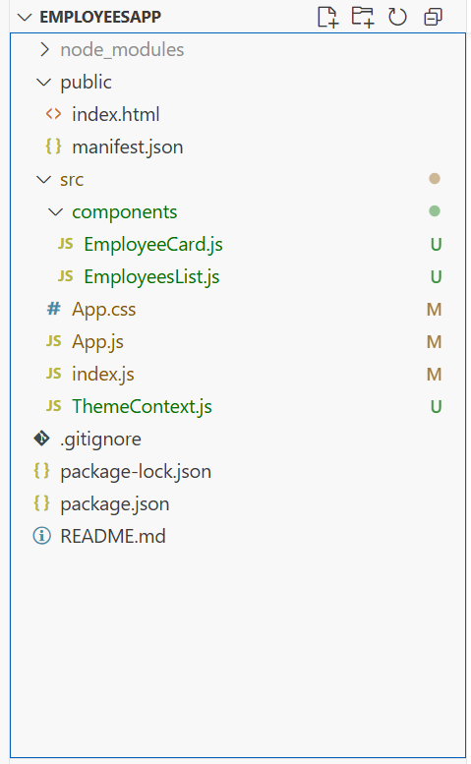

**EmployeeCard.js**  
import React, { useContext } from "react";

import ThemeContext from "../ThemeContext";

function EmployeeCard({ employee }) {

  const theme = useContext(ThemeContext);

  return (

    <div className={`employee-card ${theme}`}>

      <h3>{employee.name}</h3>

      <p>{employee.role}</p>

      <button className={`btn-${theme}`}>View Profile</button>

    </div>

  );

}

export default EmployeeCard;

**EmployeesList.js**

import React from "react";

import EmployeeCard from "./EmployeeCard";

function EmployeesList() {

  const employees = [

    { id: 1, name: "Alice", role: "Developer" },

    { id: 2, name: "Bob", role: "Designer" },

    { id: 3, name: "Charlie", role: "Manager" }

  ];

  return (

    <div>

      <h2>Employees</h2>

      {employees.map((emp) => (

        <EmployeeCard key={emp.id} employee={emp} />

      ))}

    </div>

  );

}

export default EmployeesList;

**App.js**  
  
import React, { useState } from "react";

import ThemeContext from "./ThemeContext";

import EmployeesList from "./components/EmployeesList";

function App() {

  const [theme, setTheme] = useState("light");

  const toggleTheme = () => {

    setTheme(theme === "light" ? "dark" : "light");

  };

  return (

    <ThemeContext.Provider value={theme}>

      <div className={`employee-list ${theme}`}>

        <h1>Employee Management App</h1>

        <button onClick={toggleTheme}>

          Switch to {theme === "light" ? "Dark" : "Light"} Theme

        </button>

        <EmployeesList />

      </div>

    </ThemeContext.Provider>

  );

}

export default App;

App.css  
  
/* App.css */

body {

  margin: 0;

  font-family: 'Segoe UI', Tahoma, Geneva, Verdana, sans-serif;

  background-color: #f5f5f5;

}

.container {

  max-width: 1000px;

  margin: auto;

  padding: 20px;

}

h1 {

  text-align: center;

  font-size: 32px;

  color: #333;

  margin-bottom: 20px;

}

.theme-toggle-button {

  display: block;

  margin: 0 auto 30px auto;

  padding: 10px 16px;

  background-color: #007bff;

  color: white;

  border: none;

  border-radius: 6px;

  font-size: 14px;

  cursor: pointer;

  transition: background-color 0.3s;

}

.theme-toggle-button:hover {

  background-color: #0056b3;

}

.employees-section h2 {

  color: #444;

  font-size: 24px;

  margin-bottom: 20px;

}

/* Flex layout for employee cards */

.employee-list {

  display: flex;

  flex-wrap: wrap;

  gap: 20px;

  justify-content: center;

}

/* Employee Card Styling */

.employee-card {

  background-color: white;

  border-radius: 10px;

  padding: 20px;

  width: 240px;

  box-shadow: 0 4px 10px rgba(0, 0, 0, 0.1);

  transition: transform 0.2s ease, box-shadow 0.2s ease;

}

.employee-card:hover {

  transform: translateY(-5px);

  box-shadow: 0 6px 16px rgba(0, 0, 0, 0.2);

}

.employee-card h3 {

  margin: 0;

  font-size: 20px;

  color: #222;

}

.employee-card p {

  margin: 5px 0 15px;

  color: #666;

}

/* View Profile Button */

.employee-card button {

  border-radius: 6px;

  cursor: pointer;

  transition: background-color 0.2s;

}

.employee-card button:hover {

  background-color: #218838;

}

**ThemeContext.js**  
  
import React from "react";

// Create context with default theme 'light'

const ThemeContext = React.createContext('light');

export default ThemeContext;

